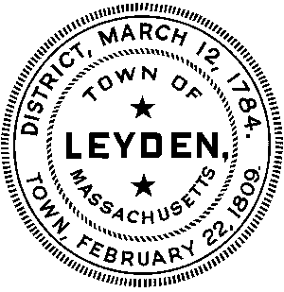
MEETING NOTICE AND AGENDA
LEYDEN Public Safety Advisory Committee
Remote GoToMeeting
https://global.gotomeeting.com/join/991839117
or Call
United States: +1 (571) 317-3122
One-touch: tel:+15713173122,,991839117#
Access Code: 991-839-117
January 13, 2022
6:30 pm
AGENDA: (Topics that the Chair reasonably anticipates to be discussed.)
6:30: - Call the meeting to order
Review minutes of Jan. 5, 2022 meeting
Review correspondence
6:45 Efficiency and Regionalization Grant
7:00 Collins Center for Public Management
7:45: Status of Leyden police services
8:00 Status of Fire, EMS and EMD in Leyden
8:10 Priorities and next steps
8:15 Public Comments and other business not reasonably anticipated
by the chair 48 hours in advance of the meeting.
8:25 Schedule Next Meeting
ADJOURN

*Please note – all times are for planning purposes Posted 1/10/22

