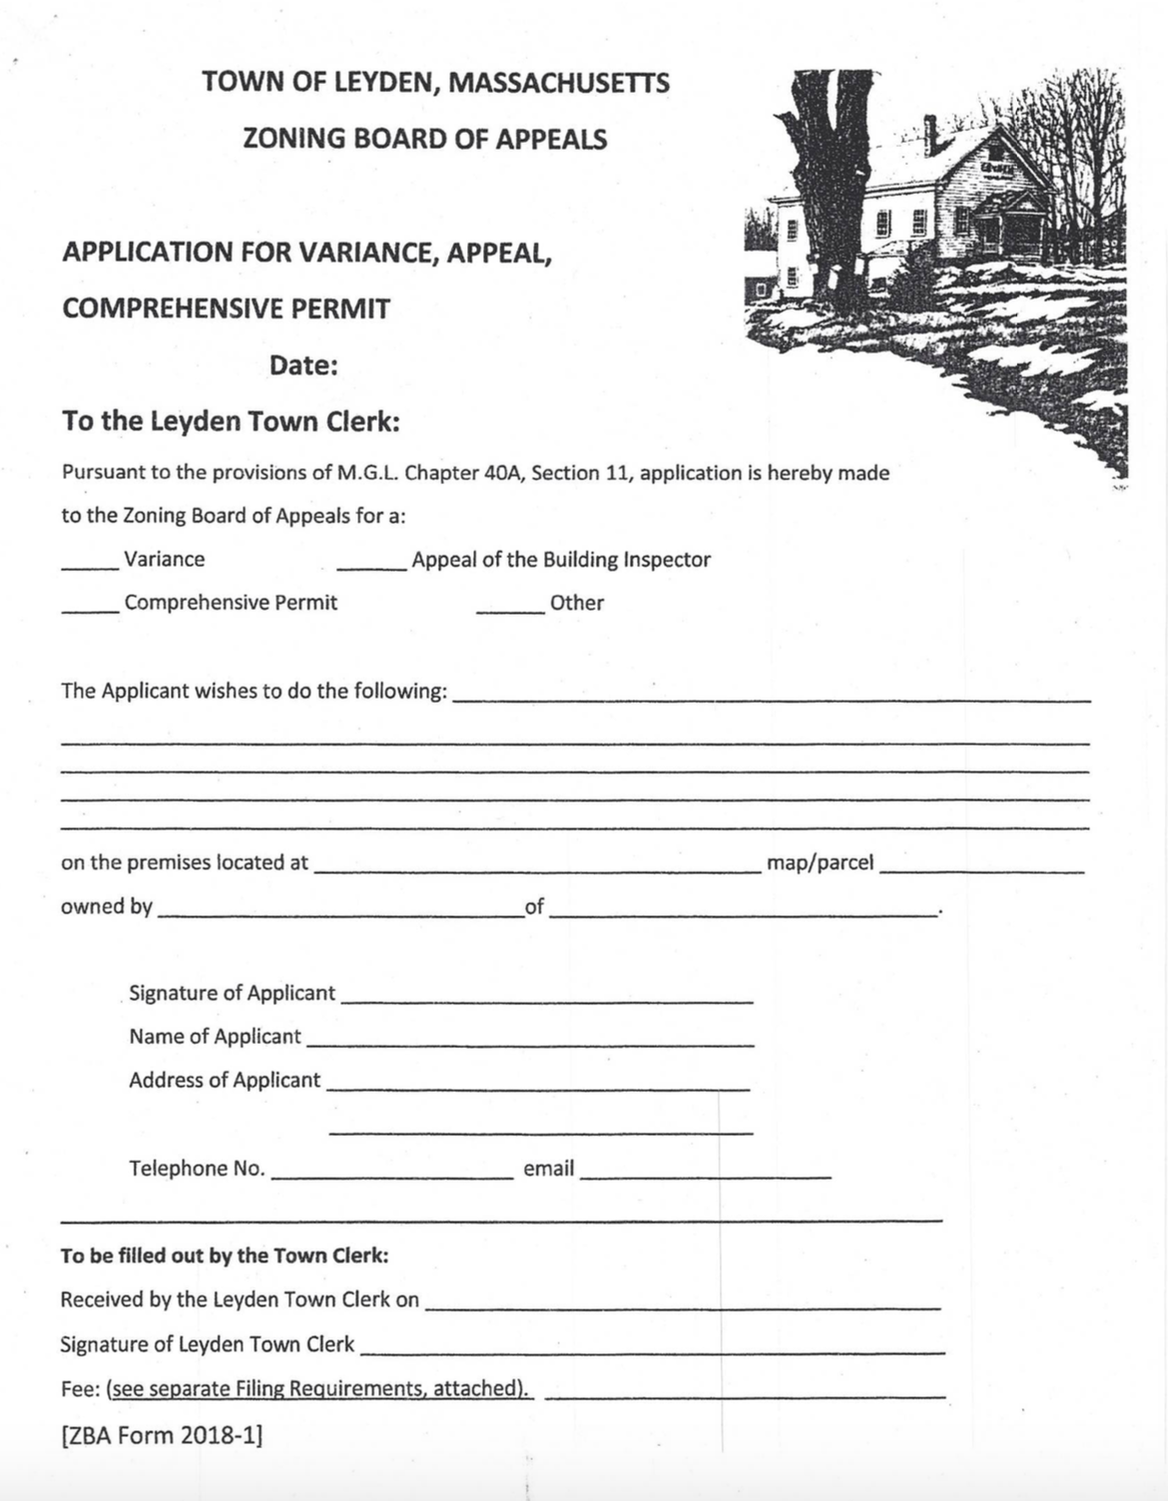

FILING REQUIREMENTS FOR THE LEYDEN ZONING BOARD OF APPEALS

1. Application form (6 copies).
2. Building permit application/denial.
3. Certified plot plan (2 copies) – Plan shall show at a minimum: existing and proposed structures, structure setbacks from Right-of-Way (ROW), side and back lot lines, location of travel way within ROW, locations of driveways, wells, septic system & wetlands. This same information shall also be submitted for any and all abutters within 150’ of the proposed activity.
4. Abutters list (to be obtained by the applicant from the Board of Assessors): Complete name and mailing address listing all parties in interest within 300’ of all applicant’s property lines, including opposite sides of public or private streets or ways, AND the Planning Boards of Leyden, Bernardston, Greenfield, Colrain, & Guilford VT.
5. Established filing fee(s): $500.00 per Application, plus $8.00 per “Parties in Interest” mailing, payable to Town of Leyden.

VARIANCES are mechanisms by which a municipal board authorizes a variation from otherwise applicable zoning requirements.

State law, Chapter 40A Section 10, requires a petitioner requesting a variance to be able to show at the time of the public hearing that:

1. There are unique circumstances relating to the soil conditions, shape, or topography of the land or structures in question and especially affecting the land and structures, but not affecting generally the zoning district in which the land or structures are located;
2. A literal enforcement of the by-law would involve substantial hardship, financial or otherwise, and;
3. Desirable relief may be granted without substantial detriment to the public good and without nullifying or substantially derogating from the intent or purpose of the zoning ordinance or by-law.

All three (3) of the above conditions must be met for favorable action on the variance request. The Applicant must show how the characteristics of the property in question prohibit what he/she is trying to accomplish.

Leyden Zoning Board of Appeals

[ZBA Form 2018-2, revised Dec 2023]