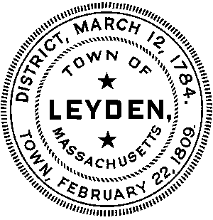
MEETING NOTICE AND AGENDA
Council on Aging Meeting
Town Office Building
7 Brattleboro Road
Tuesday, November 14, 2023
2:00 pm
Present at meeting: Chris Maguire, Amy St. Clair, Nan Rolstad, Anne Garvey, Linda Allis

- Review and approve the meeting notes from the previous meeting held on October 17, 2023.

Old Business
- Questions/concerns and follow-up from the W.Mass funeral directors presentation?
Winners of the Claris tablets: Ruth Tuller, Peggy Brown, Sharon Fontaine, Richard Allis. Chris Maguire is holding one to be awarded.

New Business
- Next month’s topic will be a presentation on sheep herding dogs.

- Any suggestions for next month’s luncheon?

- There has been confusion and contradictions between council members and other officials in Leyden. Do we need to set up procedures/protocols regarding our interactions with our peers and other community members? How do we avoid this going forward?

- Going forward, when purchasing any items and/or services for the COA, must follow the correct procedures. Reimbursement due to use of personal credit cards is not allowed.

- I’ve been advised that it would be good to have another council member trained in ServSafe food management.

- Amy has heard that the town hall will be closed for 3 months in the winter. How will we deal with that?

- Nan has suggested we think about having a breakfast/coffee time, instead of a luncheon.

- Merry has prepared a notice/description of the Grab and Go meals for the newsletter. We’ll look at this before it gets published.

- Any other topics for discussion?

Posted at 8:15 PM on Wednesday, November 8, 2023 by Paul McLatchy III, Town Clerk

